How to check for updates on your AWE computer if you are connected to a network:
Log into the Admin Panel:
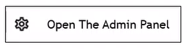
Navigate to the Software Update tab and click the Run Update button:

Click the Update from Web:
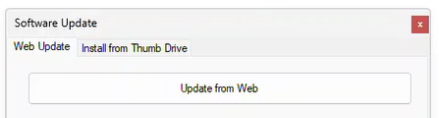

You will receive a message; Your computer is up to date or there are updates available.
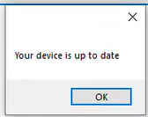
If there are updates available, you can run them all from here.
-------------------------------------------------------------------------------------------------------------------

If your computer is not connected to a network, you can export all the updates from the customer portal: (https://portal.awe-net.com/)
You will need to export all missing updates and install each. I.E. if you are running software 3.0.0.9,
You will need to install update310, 311,312, 313.
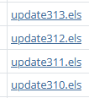
Export to the update(s) to a flash drive.
Insert the flash drive into the AWE computer.
Log into the Admin Panel:
Navigate to the Software Update tab and click the Run Update button:
Click the Install from Thumb Drive Button:
Click the box with the 3 dots and navigate to the flash drive and select the update file and click Open:
